
  COURSEWORK SPECIFICATION
  ECM3412 – Nature-Inspired Computation
  Module Leader: Alberto Moraglio
  Academic Year: 2026/27

Title: Programming Task & Report
Submission deadline: 11 November 2026 (12:00 noon)
This assessment contributes 40% of the total module mark and will allow you to demonstrate what you have learned by assessing the following intended learning outcomes:
- demonstrate a clear understanding of the difficulties associated with certain intelligence-related tasks that we would wish to program computers to do;
- evaluate a difficult problem and determine the likely best algorithm selection;
- implement software for addressing real-world optimisation problems with nature-inspired methods;
- digest and communicate succinctly information from publications in the field to individuals unfamiliar with the material.
How can feedback help you improve your work?
The feedback you received on ECM1410's coding assignment and ECM1414's algorithm design assignment provides guidance on problem analysis, algorithm design and coding that directly applies to this assessment. Feedback from this assessment will help clarify your understanding of key concepts ahead of the exam.

Instructions

Task
What you will do in this assignment is write a ‘research paper’ on the application of ant colony optimisation (ACO) to the problem of bin packing. You will need to research the various nature-inspired algorithms that have been applied to this problem and relevant variations, implement the ACO approach and then carry out a variety of experiments to help find out what parameters for the algorithm are best for this problem. The implementation must be in Python. In the remainder of this document, the following is provided: details of the problem, the basic details of the algorithm, the requirements for the literature review and a description of the experiments you should carry out. The final section indicates what should be in your report to be handed in.

The Bin-Packing Problem
The bin-packing problem (BPP) involves n items, each with its own weight. Each item must be placed in one of b bins. The task is to find a way of placing the items into the bins in such a way as to make the total weight in each bin as nearly equal as possible. E.g., if there are 6 items with weights as follows: (17, 12, 19, 6, 4, 28) and we place them into 3 bins as follows indexing from 1:
(bin1: 1, 3) (bin2: 4) (bin3: 2, 5, 6)
then bin1 has weight 36 (17+19), bin2 has weight 6, and bin3 has weight 44 (12+4+28). These are quite different, so it is a poor solution. We can measure the solution quality by taking the difference d between the heaviest and lightest bins – in this case d = 38. What we want to do here is to minimise this difference. A far better solution in this case is:
(bin1: 1, 2) (bin2: 3, 4, 5) (bin3: 6)
with d = 1. You will need to create a construction graph to represent the problem. This should be a structure which contains the pheromone values for every possible decision made by the ants. For instance, a problem with k items and b bins will look like this:
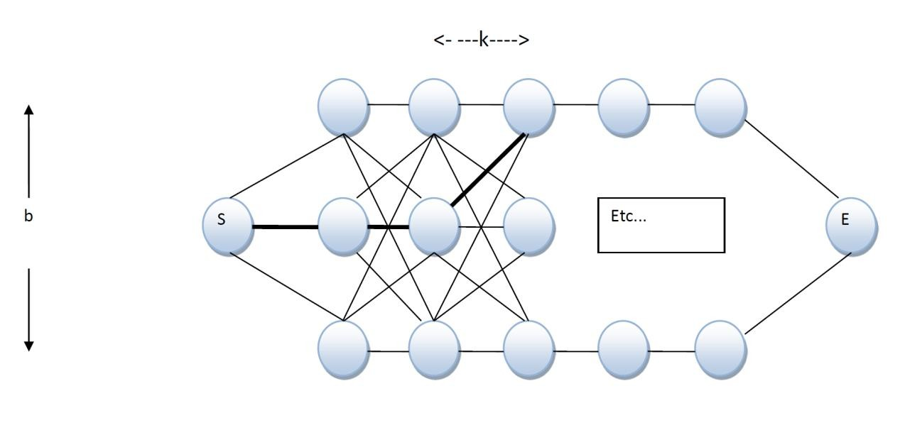
Therefore an ant travelling from the start (S) to the end (E) will have to place each of the k items into one of the b bins. The route taken by an ant marked in bold shows that item 1 will be placed in bin 2, item 2 will also be placed in bin 2, and item 3 will be placed in bin 1.
The fitness of a route is worked out by calculating the difference d between the heaviest and lightest bins, where the goal is to minimize this difference. There are two specific bin-packing problems I want you to address. In each problem, a set of items must be packed into a fixed number of bins (b). In problem BPP1, there are 600 items to be packed into b = 12 bins, where the weight of item i (for i = 1, …, 600) is given by w(i) = 2i + 1. In problem BPP2, there are 400 items to be packed into b = 40 bins, where the weight of item i (for i = 1, …, 400) is given by w(i) = (i²)/4.

The Ant Colony Optimisation Algorithm
Implement the ACO like this:
- Randomly distribute small amounts of pheromone (between 0 and 1) on the construction graph.
- Generate a set of p ant paths from S to E (where p is a variable and specified below).
- Update the pheromone in your pheromone table for each ant’s path according to its fitness.
- Evaporate the pheromone for all links in the graph.
- If a termination criterion has been reached, then stop. Otherwise return to step 2.
Termination Criterion: When the algorithm has reached a maximum number of fitness evaluations (generated paths). The result is then the fitness of the best ant in the population at the end.
Generating Ant Paths: An ant will traverse your construction graph by making a decision at each new item it comes to (i.e. an ant at S can choose to go to bin 1, 2 or 3 in the illustration above). This selection is made at random, but biased by the amount of pheromone on the choices ahead (e.g. if an ant is placed at position S and bin 1 has a pheromone value of 0.5, bin 2 has a pheromone value of 0.8 and bin 3 has a pheromone value of 0.1, the ant should have a 5/14 chance of selecting bin 1, an 8/14 chance of selecting bin 2, and a 1/14 chance of selecting bin 3). This should be repeated for all k variables and b bins. There is no local heuristic for this implementation.
Pheromone Update: Once the fitness has been computed, the pheromone must be updated accordingly. With the bin packing problem, we want to reward paths that lead to bin packs with smaller differences. Therefore the pheromone update for the path will be 100/(fitness+1).
Pheromone Evaporation: Finally, the pheromone on all paths must be evaporated. This is achieved simply by multiplying all paths within the construction graph by (1-e) with the evaporation rate e specified below.

Implementation and Experimentation
Implement the described ACO in such a way that you can address the BPP problems, and then run the following experiments and answer the subsequent questions. Note that, in all of the below, a single trial means that you run the algorithm once and stop it when 10,000 fitness evaluations have been reached. Different trials of the same algorithm should be seeded with different random number seeds.
Run five trials of the ACO with p = 50 and e = 0.05
Run five trials of the ACO with p = 50 and e = 0.30
Run five trials of the ACO with p = 10, and e = 0.05
Run five trials of the ACO with p = 10, and e = 0.30
Do all of the above, first on BPP1 and then on BPP2 (as defined in the Bin Packing Problem section). Record the best fitness reached at the end of each trial and any other variables you think will be important.

Report
Your submission should be a PDF using one of the document template posted on ELE. Please do not include your name but include your candidate number on the cover page.
The paper should have a maximum of 8 pages (Cover page and references are not counted towards the page limit). The report should include a short literature review on nature-inspired approaches to the binpacking problem and a description of the results of your experiments where tables and/or graphs of results should take up no more than 2 pages. In the remaining space, write a ‘Discussion and Further Work’ section including your answers to the following questions.
Question1: Which combination of parameters produces the best results?
Question 2: What do you think is the reason for your findings in Question 1?
Question 3: How do each of the parameter settings influence the performance of the algorithm?
Question 4: Do you think that one of the algorithms in your literature review might have provided better results? Explain your answer.

In your answers, describe your observations of the results, and describe any tentative explanations or conclusions you feel like making, and describe any additional experiments you implemented, including their methodology, results, and what insights they provided.
Your report must have exactly the structure outlined below:
Abstract
- Introduction
- Literature Review
  - Ant Colony Optimisation
  - Genetic Algorithm
  - Particle Swarm Optimisation
  - Other Nature-Inspired Approaches
  - Critical Analysis
- Description of Results
  - Experimental Setup
  - Experimental Results
- Discussion
  - Answer to Question 1 4.2 Answer to Question 2 4.3 Answer to Question 3
4.4 Answer to Question 4
- Further Experiments
- Conclusions
References

Marking criteria

Submission
In ELE2, you should submit a single compressed (.zip) folder which contains:
Paper: a PDF file with your report using the provided template;
Code: a single source file (.py) with clearly commented code;

Marking Scheme
Quality of Literature Review (15%): The degree to which the report contains a comprehensive review of nature-inspired approaches for bin-packing problems with critical analysis of their strengths and limitations. Correct and efficient implementation of the algorithm (10%): The degree of correctness of the ant colony algorithm implementation, including proper construction graph, fitness function, and adherence to specified ACO components.
Quality of code documentation (5%): The degree of clarity of code comments and documentation. Correct results from the ACO runs (20%): The degree to which the experimental results demonstrate proper execution of the specified experiments on both BPP1 and BPP2 problems with valid fitness values and methodology.
Quality (e.g. readability & usefulness) of tables and graphs (15%): The degree to which the report contains clear and informative visual presentations of experimental results within the 2-page limit for visual materials. Answers to Questions 1-4 (20%): The degree to which the report contains insightful and well-supported responses to the four required questions about parameter performance and algorithmic comparisons. Further Experiments (10%): The degree to which additional experiments beyond the required ones are implemented, including quality of methodology, results analysis, and insights provided.
Conclusions (5%): The degree to which the report contains well-synthesized conclusions summarizing key findings and contributions.
________________________________________________________
Over length submissions per page (exceeding 8 pages) -10%
Provided template and structure not used -20%

